# **6W 5V FLYBACK SMPS DESIGN**

$V_{in}$ = 120V(60Hz) or 230V(50Hz) ${}_{-}^{+}{\%15}$ => 100 $V_{AC}$ < $V_{in}$ < 265 $V_{AC}$

85x $\sqrt{2}$ = 120V Eff (Efficient) = 0,8

̬△ $V_{CAP}$ = % ${}_{-}^{+}{\%15}$

120 x 0,85 = 102V

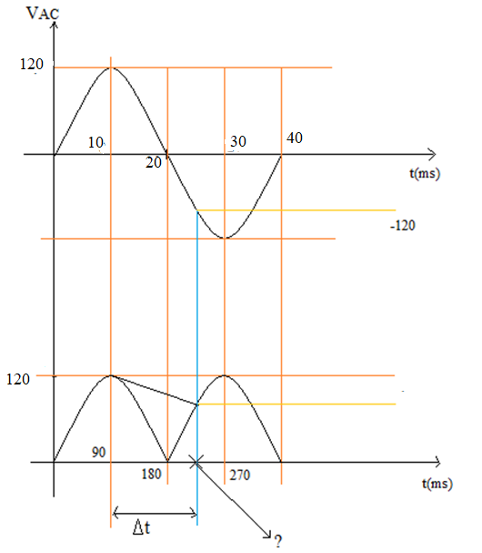



Note: ? = wt

120 x $\sin{wt}$ = -102V

wt = 238°, -58,21°

△t = $\frac{238-90}{180}$ x 10ms = 8,2ms

△ $V_{AVG}$ = $\frac{120+ 102}{2}$ = 111V

$I_{{CAP}_{DISCHARGE}}$ = $\frac{6W/0,8}{111}$ = 67,56mA

△V = 120 – 102 = 18V

$\frac{67,56mA}{C}$ x 8,2ms = 18V => C = 30,7uF

230 $V_{AC}$ ${}_{-}^{+}{\%15}$ => $\frac{1uF}{1W}$

Universal input => $\frac{2uF}{1W}$

So 68uF(400V) CAP is chosen

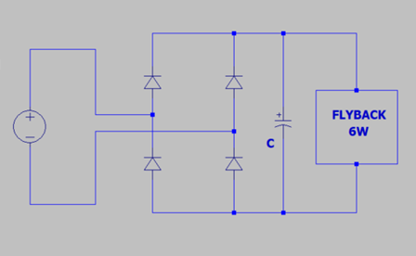

## **# D, L and $L_{P}$

#**

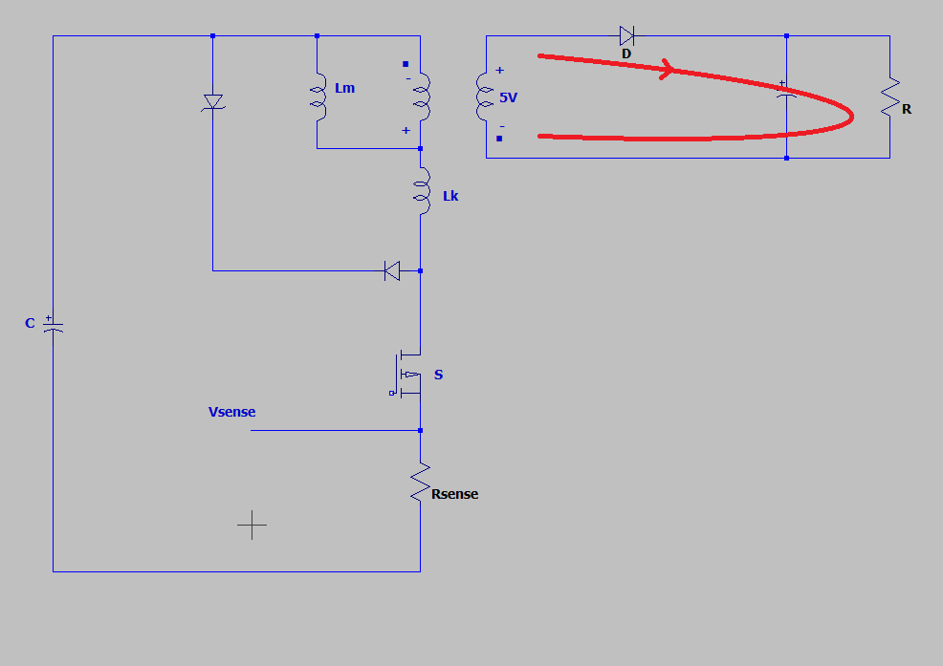

$\frac{Primer}{Seconder}$ = 20 => $\frac{Primer}{5V}$ = 20 => $V_{Reflected}$ = 100V

102 x D = 100 x (1 – D) => D = 0,495

$P_{in}$ = $\frac{P_{o} }{η}$ = $\frac{6 }{0,8}$ => $P_{in}$ = 7,5W

D = $\sqrt{\frac{2 x P_{in} x L_{peak}}{T}}$ x $\frac{1}{V_{in} }$ => 0,495 = $\sqrt{\frac{2 x 7,5 x L}{10u }}$ x $\frac{1}{102 }$ => $L_{pri}$ = 1,7mH

P = $\frac{1}{2} x L_{pri} x$ ${(I_{L_{peak}})}^{2}$ x f => 7,5 = $\frac{1}{2} x 1,7 x {10}^{-3} x$ ${(I_{L_{peak}})}^{2}$ x 66000 => $I_{L_{peak}}$ = 0,366A

$I_{S(RMS)}, I_{C(RMS)}, I_{pr(RMS)}$

## $V_{C(AVG)}$**# #**

= 111V => $\frac{111}{1,7mH}$ x $D_{AVG}$ x $\frac{1}{66000}$ = 0,366A => $D_{AVG}$ = 0,37

$I_{S(RMS)} ≅ I_{C\left(RMS\right)} ≅ I_{pr(RMS)}$ (@66kHz)

$\frac{1}{\sqrt{3}}$ x $I_{L_{peak}}$ x $\sqrt{D_{AVG}}$ => $\frac{1}{\sqrt{3}}$ x 0,366 x $\sqrt{0,37}$ = 0,128 $A_{RMS}$

## **# Snubber Power and RCD Snubber**

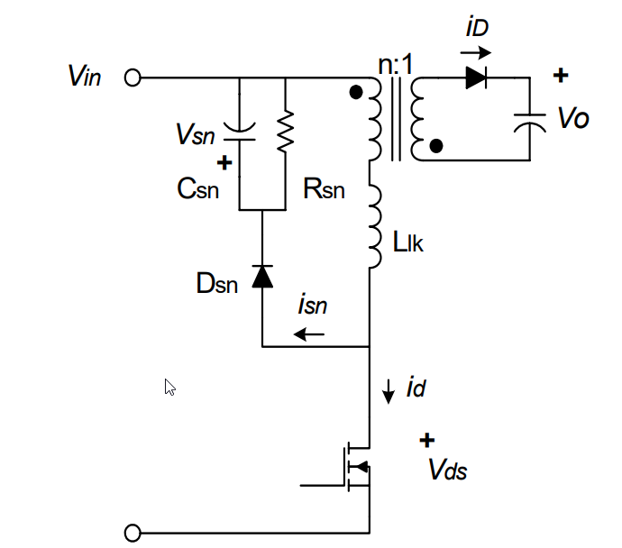

$V_{sn}$ should be 2 $\sim$ 2,5 times of n $V_{O}$.

Therefore $V_{sn}$ = 200V

$L_{K}$ = 0,01 x 1,7mH => $L_{K}$ = 17uH

$\frac{1}{2}$ x $L_{K}$ x ${I_{L_{peak}}}^{2}$ x $f_{s}$ = 0,0748W So $P_{sn}$ > 0,0751W

△t = $\frac{L_{K}}{ V_{sn}-nV_{O}}$ x $I_{L_{peak}}$ = $\frac{17u}{200 -100}$ x0,366 => △t = 62,2ns

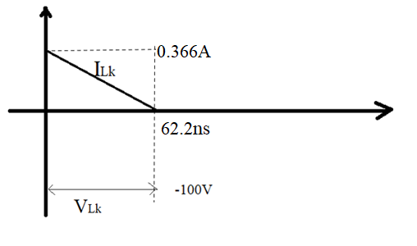

$I_{Lk}$ = 0,366A - $\frac{100}{17uH}$ xt

$I_{Lk}$ = 0 => △t = 62,2ns

$\int_{0}^{62,2ns}{100 x (}$ 0,366-5,882 x ${10}^{6}$ x t)dt = 100x0,366 x 62,2x ${10}^{-9}$– 100 x 5,882 x ${ 10}^{6}$ x $\frac{{(62,2x{10}^{-9} )}^{2}}{2}$ =>

= 1,139u joule

$P_{Snubber}$ =66000 x [$\frac{1}{2}$ x 17 x ${10}^{-6}$ x ${0,366}^{2}$ + 1,139 x ${10}^{-6}$] => $P_{Snubber}$ = 0,15W

Rsn = $\frac{{V_{sn}}^{2}}{P_{Snubber}}$ => $\frac{{200}^{2}}{0,15}$ => Rsn = 266,667kΩ $≅$ 330kΩ

△ $V_{sn}$ = $\frac{V_{sn}}{C_{sn}R_{sn}f_{s}}$ => $C_{sn}=$ = $\frac{100}{10 x 330000x66000}$ = 470pF => $C_{sn}$ = 470pF

When the converter operates in DCM at the maximum input voltage and full-load condition, the $I_{peak2}$ is obtained by:

$I_{peak2}$ = $\sqrt{\frac{{2P}_{in}}{f_{s}L_{m}}}$

$I_{SEC(RMS)}$

## **# #**

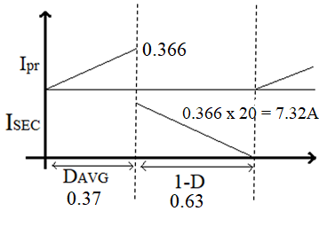

$I_{SEC(RMS)}$ = $\frac{1}{\sqrt{3}}I_{SEC\left(Peak\right)}$ $\sqrt{Duty}$ => $\frac{1}{\sqrt{3}}7,32\sqrt{0,63}$ => $I_{SEC(RMS)}$ = 3,354 $A_{RMS}$

$$I_{sec(RMS)}$$

△V

## **# Output Diode #**

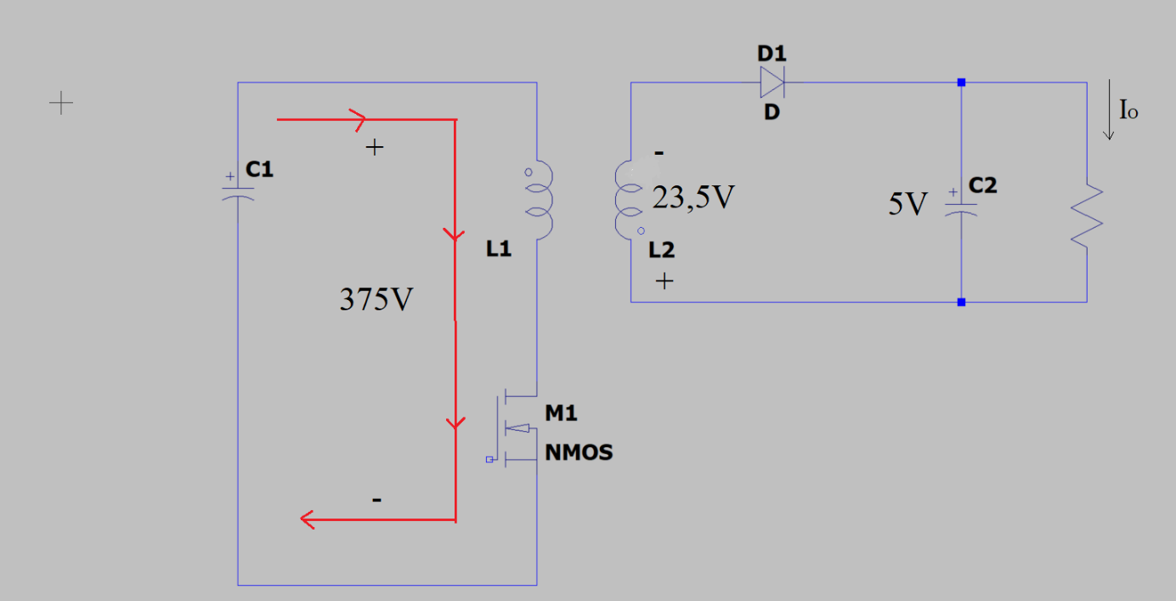

265 $\sqrt{2}$ = 375V => 375/20 = 18,75V

$V_{D(peak)}$ = 18,75 +5 => $V_{D(peak)}$ = 23,5V

70V diode is suitable. It is SB270.

$I_{D(AVG)}$ = $\frac{6W}{5V}$ => $I_{D(AVG)}$ = 1,2A

$V_{F}$ = 0,7V $R_{ØJA}$ = 15 °C/W

$P_{LossD}$ = 0,7 x 1,2 => $P_{LossD}$ = 0,84W

△T = 0,84 x 15°C => △T = 12,6°C

## **# Snubber Diode ( $D_{sn})$

$V_{DS(peak)}$#**



= 575V

$V_{D_{sn}}$ = 1000V

$V_{DS(RMS)}$ < $V_{D_{sn}(RMS)}$ => So UF4007can be choose.

## **# MOSFET #**

DRAIN Voltage ........................................................-0.3 V to 725 V

DRAIN Peak Current: LNK623 .................................400 (600) mA

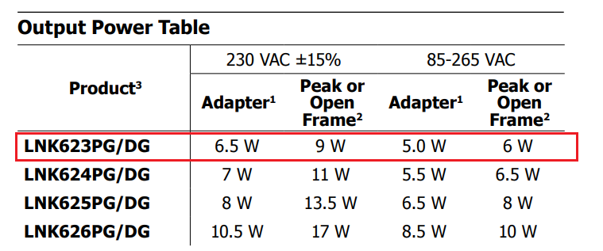

## **# TRANSFORMER #**

|  |  |  |  |  |  |  |  |
| --- | --- | --- | --- | --- | --- | --- | --- |
|  |  |  |  |  |  |  |  |
|  | **Primer = Seconder  n** | $$P_{0}$$ | $$I_{pr(RMS)}$$ | $$I_{SEC(RMS)}$$ | $$L_{pr}$$ | $$I_{L_{peak}}$$ |  |
|  | 20 | 6W | 0,128ARMS | 3,354ARMS | 1,7mH | 0,336A |  |
|  |  |  |  |  |  |  |  |

Beginning => EF20: 13W, @66kHz, Ae =32,2 ${mm}^{2}$, Aw =61,8 ${mm}^{2}$

* L x I = N x Ø => L x I = N x B x Ae

1,7mH x 0,366A = N x 0,2T x 32,2 x ${10}^{-6}$ => $N_{pr}$ = 96.6 => $N_{pr}$ = 100

$N_{pr}$: $N_{sec}$ => 100 : 5 => ${ N}_{sec}$ = 5

Let I = 5A/ ${mm}^{2}$ be choosen.(3 < J < 8)

5A => 1 ${mm}^{2}$

0,128 => 0,0256 ${mm}^{2}$ => ${ r }_{pr}=0,1mm$ ${ Ø }_{pr}$ = 0,2mm (primer area)

Acu = 0,0314 ${mm}^{2}$

$I_{SEC(RMS)}$ = 3,354 $A_{RMS}$

5A => 1 ${mm}^{2}$ 0

3,354A => 0,6708 ${mm}^{2}$ => ${ r }_{sec}=0,47mm$ ${ Ø }_{sec}$ = 0,94mm

4x ${ 0,47Ø }_{sec}$ (seconder area)

But 0,94mm enamel cable can be hard to bent. Also there is the skin effect too. It should not be higher than 0,5mm.

Acu = 0,7 ${mm}^{2}$

Acu = 100 x 0,0314 + 5 x 0,7 = 6.64 ${mm}^{2}$

Winding factor = (Acu / Aw) x 100 = 6,64 / 61,8 = %10,07

%10,07 < %25 => The area of the windings fits easily.

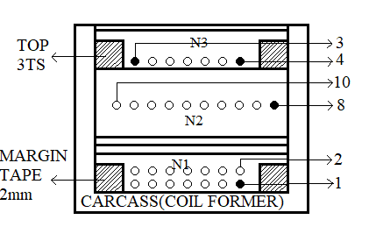

$N_{1}$: 100 x $T_{S}$ x 1P x 0,2mm 2UEW-F

$N_{2}$: 5 x $T_{S}$ x 3P x 0,56mm TIW

$N_{3}$: 5 x $T_{S}$ x 1P x 0,2mm 2UEW-F

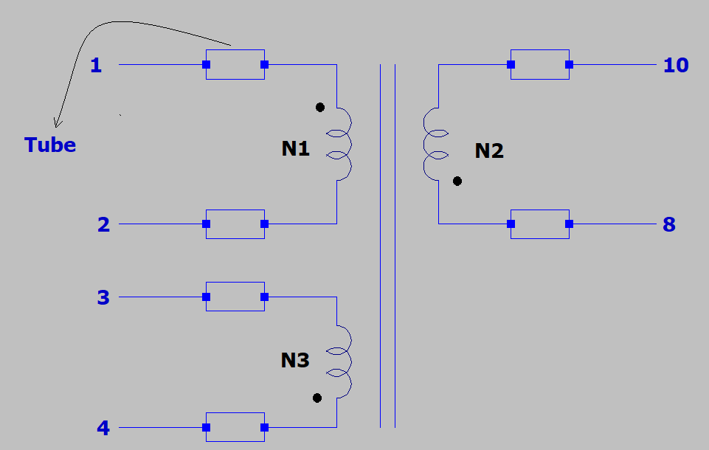

## **# Full Bridge Rectifier**

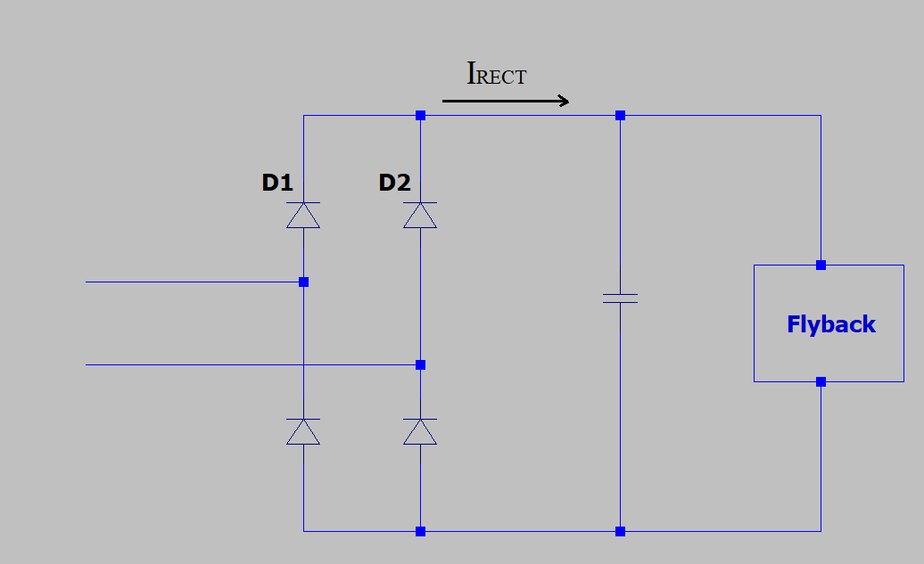

$P_{in}$ =7,5W

$V_{{CAP(AVG)}_{min}}$ =111V

$I_{{RECT}_{AVG}}$ = $\frac{7,5}{111}$ => $I_{{RECT}_{AVG}}$ = 67,5mA

$I_{{D1}_{AVG}}$ = $I_{{D2}_{AVG}}$ = $\frac{67,5}{2}$ => $I_{{D1}_{AVG}}$ = $I_{{D2}_{AVG}}$ =33,75mA

For MB6S:

$P_{D1}$ = 33,75x ${10}^{-3}$ x 1 => $P_{D1}$ = 0,03375W

$R_{ØJA}$ = 85°C/W

4 x $P_{D1}$ = 4 x 0,03375 = 0,135W

△T = 0,135 x 85 => △T $≅$ 11,475°C

## **# NTC - Common Mode Choke

$I_{in(RMS)}$ #**

= $\frac{7.5W}{85V_{RMS}} x \frac{1}{0,7}$ => $I_{in(RMS)}$ = 126m $A_{RMS}$

NTC = NTB02-010MV 10Ω $C_{Test}$ = 60uF @240 $V_{AC}$

$R_{NTC}$ = 1,87Ω @107mA

$T_{NTC}$ = 90°C => It is very high value. So it is not acceptable.

NTC = B57153S0100 10Ω $C_{Test}$ = 100uF @230 $V_{AC}$

$C_{Test}$ = 400uF @110 $V_{AC}$

$R_{NTC}$ = 4Ω @126mA

$T_{NTC}$ = 60°C

**For Line filter :**

Common mode => 0,8A 40mH 400uH(leakage) R = 1,1Ω

## **# Output Capacitor #**

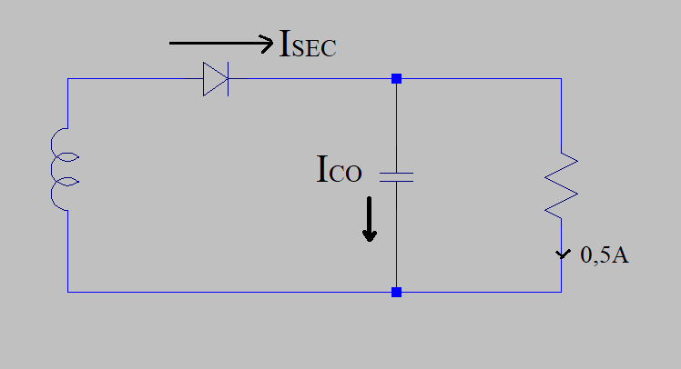

$\frac{6W}{5V}$ = 1,2A

$I_{CO(RMS)}$ = 1,736 $A_{RMS}$ (@100kHz)

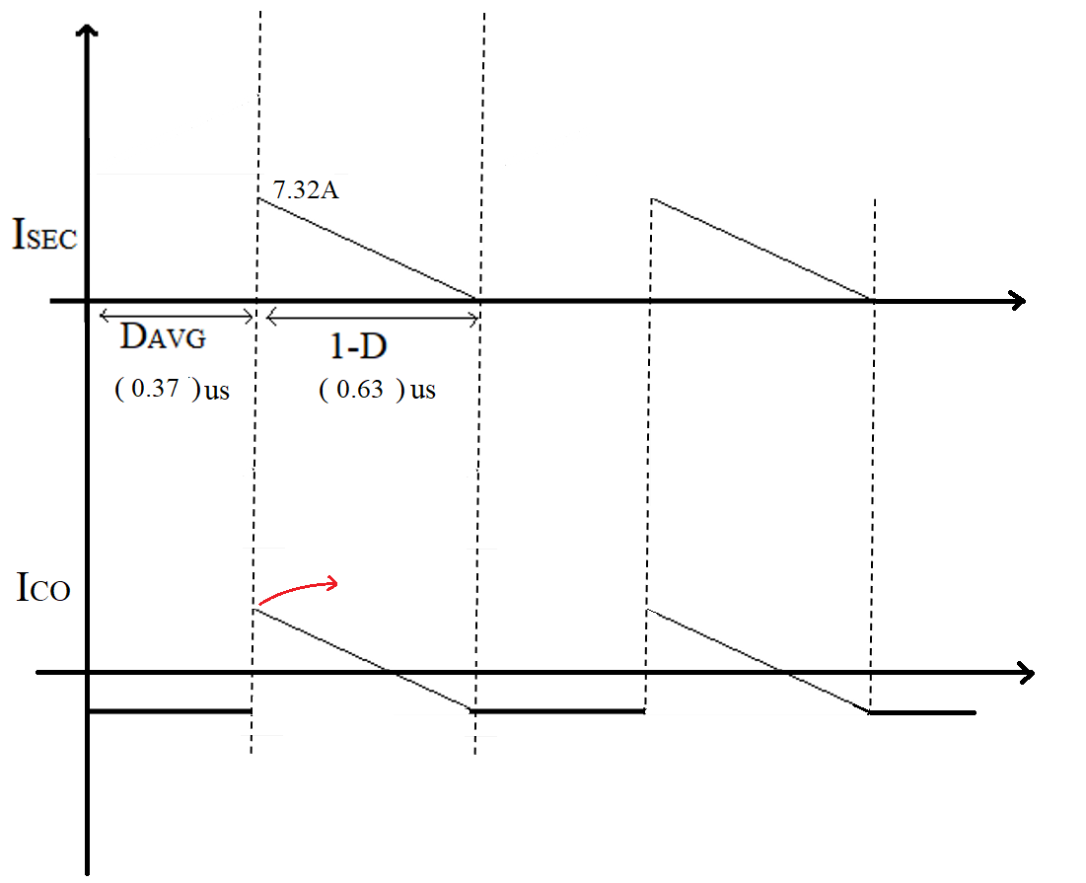

So we chose **PKLH-016V222MH200-T/A5.0**